

**TCC 3141 - Cloud Computing Group Assignment**

Trimester 1, Session 2021/2022

Lab session: 1CV

Group Name: Lemon tea

| **No.** | **Student ID** | **Student Name** | **Major** |
| --- | --- | --- | --- |
| 1 | 1171103091 | Chi Chyun Horng | ST |
| 2 | 1181302827 | Tai Yu Zhe | ST |
| 3 | 1171101515 | Lee Zhe An | ST |
| 4 | 1171102946 | Tan Kai Zhe | ST |
| 5 | 1181302975 | Tay Kai Jun | AI |

## 

**TCC 3141 Cloud Computing**

# Assessment Rubric

| Evaluation Item | Not Demonstrated | Does Not Meet Expectations | Meets Expectations | Exceeds  Expectations | **Points**  **Earned** |
| --- | --- | --- | --- | --- | --- |
| **App Implementation** |  | | | |  |
| * · Cloud storage | 0 | 1 | 2 | 3 |  |
| * · Chart Maker | 0 | 1 | 2 | 3 |  |
| * · Enhanced user experience | 0 | 1 | 2 | 3 |  |
| * · One new function | 0 | 1 | 2 | 3 |  |
| * · Working prototype | 0 | 1 | 2 | 3 |  |
|  | | | | | **/15** |
| **GitHub** | | | | | |
|  | | | | | |
| Project file | 0 | 1 | 1.5 | 2 |  |
| License | 0 | 1 | 1.5 | 2 |  |
| Read Me | 0 | 1 | 1.5 | 2 |  |
| Usage Manual | 0 | 1 | 1.5 | 2 |  |
| Version control | 0 | 1 | 1.5 | 2 |  |
|  |  |  |  |  |  |
|  | | | | | **/10** |
|  | | | | | **/25** |
| **TOTAL POINTS** |  | | | | **/10** |
| **Extra: Team Work (4%)** | | | | | |
| Roles and tasks | 0 | 1 | 1.5 | 2 |  |
| Experience Summary | 0 | 1 | 1.5 | 2 |  |
|  |  |  |  |  | **/4** |
|  |  | | | | **/14** |
| **Penalty Points**  Late Project, Plagiarism | Plagiarism (-5 marks)  Late submission (-1 mark for each consecutive 24-hour) | | | | **-** |
| **FINAL POINTS** | | | | |  |

Remarks:

|  |  |
| --- | --- |
|  | |  | | --- | |

**Declaration:** We agree that all members deserve equal marks from this assignment.

Write down the Stud ID (clearly) and signed (by all members):

| **Stud_ID** | **Date** | **Signature** |
| --- | --- | --- |
| 1171103091 | 11/2/2021 |  |
| 1181302827 | 11/2/2021 |  |
| 1171101515 | 11/2/2021 |  |
| 1171102946 | 11/2/2021 |  |
| 1181302975 | 11/2/2021 |  |

# **Table of Contents**

**Assessment Rubric** **2**

**Table of Contents** **5**

**License** **6**

**Read Me** **7**

**Usage Manual** **8**

**Link to Github 14**

# 

# License

# 

MIT License

Copyright (c) 2021 1171103091 Chi Chyun Horng, 1181302827 Tai Yu Zhe, 1171101515 Lee Zhe An, 1171102946 Tan Kai Zhe, 1181302975 Tay Kai Jun.

Permission is hereby granted, free of charge, to any person obtaining a copy of this software and associated documentation files (MyBMIUSR_LemonTea), to deal in the Software without restriction, including without limitation the rights to use, copy, modify, merge, publish, distribute, sublicense, and/or sell copies of the Software, and to permit persons to whom the Software is furnished to do so, subject to the following conditions:

The above copyright notice and this permission notice shall be included in all copies or substantial portions of the Software.

THE SOFTWARE IS PROVIDED "AS IS", WITHOUT WARRANTY OF ANY KIND, EXPRESS OR IMPLIED, INCLUDING BUT NOT LIMITED TO THE WARRANTIES OF MERCHANTABILITY, FITNESS FOR A PARTICULAR PURPOSE AND NON-INFRINGEMENT. IN NO EVENT SHALL THE AUTHORS OR COPYRIGHT HOLDERS BE LIABLE FOR ANY CLAIM, DAMAGES OR OTHER LIABILITY, WHETHER IN AN ACTION OF CONTRACT, TORT OR OTHERWISE, ARISING FROM, OUT OF OR IN CONNECTION WITH THE SOFTWARE OR THE USE OR OTHER DEALINGS IN THE SOFTWARE.

# Read Me

**TCC-3141---Cloud-Computing**

**BMI application**

1. This application aims to record/save the BMI every time users calculate their latest BMI.
2. This application is created by using https://appinventor.mit.edu
3. The app can display charts to show the recorded BMI using chartmaker (https://github.com/MillsCS215AppInventorProj/chartmaker)
4. A new health monitoring function has been added.

**Extension guideline**

1. Download the (MyBMIUSR(LemonTeaversion).aia) .
2. Go to the link https://appinventor.mit.edu/.
3. Import (MyBMIUSR(LemonTeaversion).aia) to the appinventor.mit.
4. Download (edu.mills.appinventor.ChartMaker.aix) and import to the appinventor.mit in order to view charts.

# Usage Manual

## 

Users first will bring to Screen one when they start the program which is the main menu of the Program. The screenshot shows screen one on the phone.

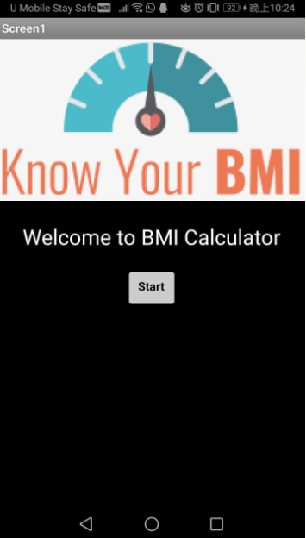

After pressing the start button, it will bring to screen two and users can input the value to calculate the BMI. The output shows the blocks in MIT App Inventor and the output screen in the phone.

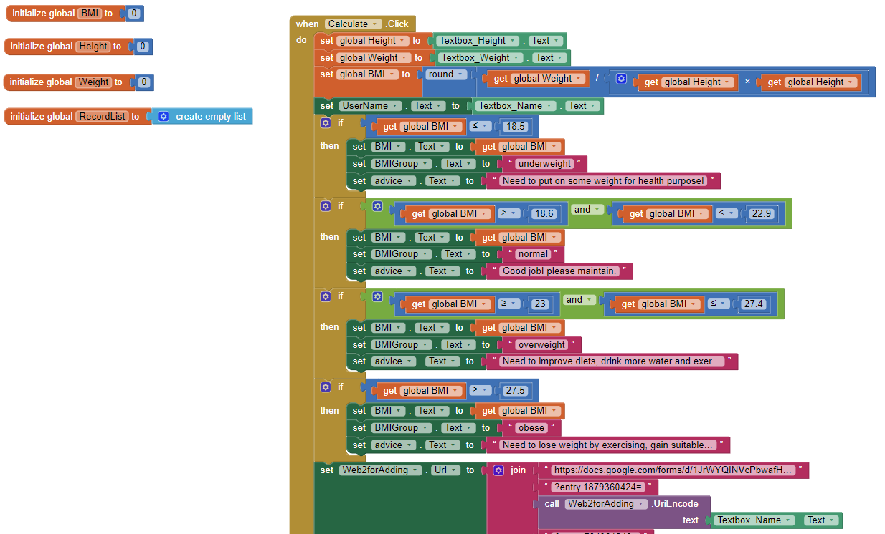

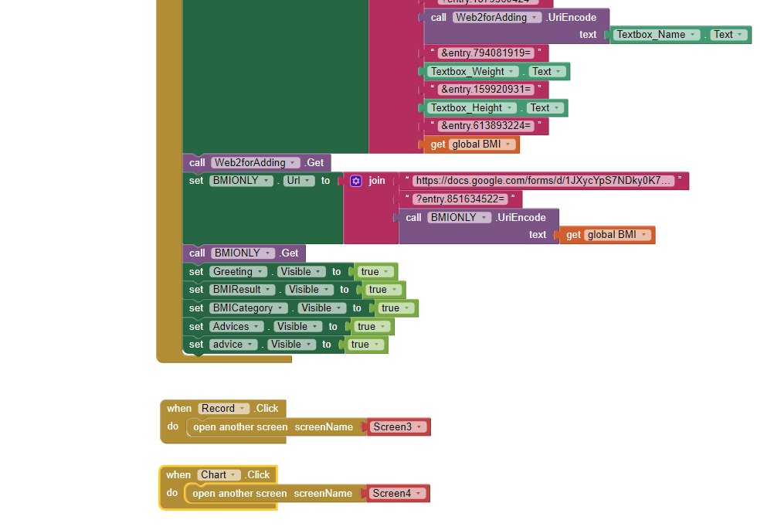

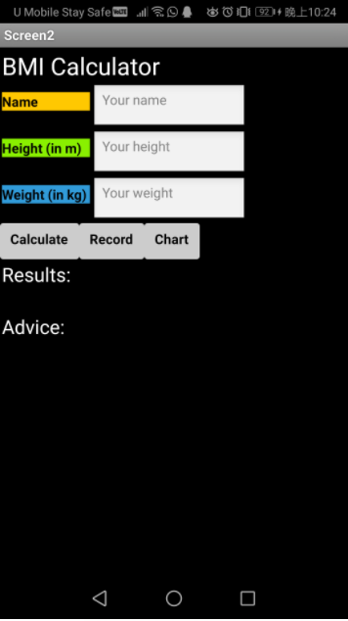

Now the user can input the value, after that the system will calculate the BMI. The system will show the result and the advice after the calculation.

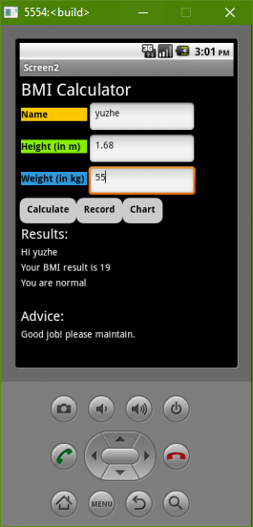

After the calculation is done, the system will store the data in the google drive file which was created by our group members. The output will be like this:

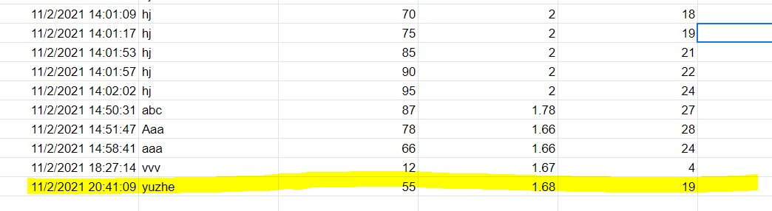

Now users can press the record button and it will bring us to screen 3. In this screen, the program will show the record data. The output includes time, user’s input name, weight, height and the BMI.

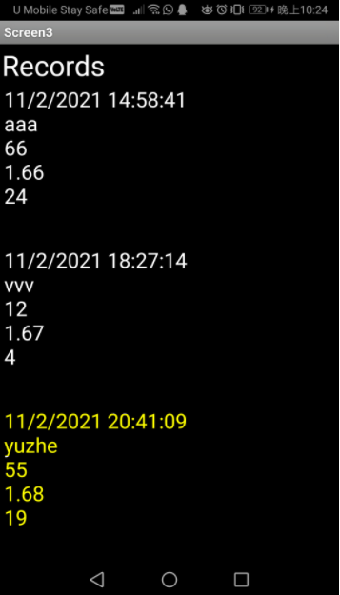

Blocks in MIT App Inventor on screen 3:

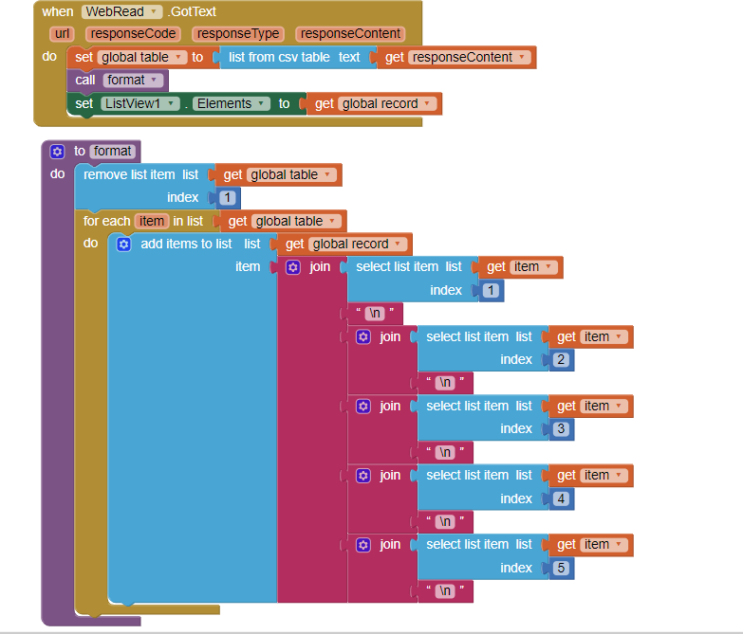

And lastly is the chart button. This function will show the average of the BMI value in Bar chart type and Pie chart type. All of the chart output will be output on screen 4. Users can choose which type of chart they want to output. The output will be like this:

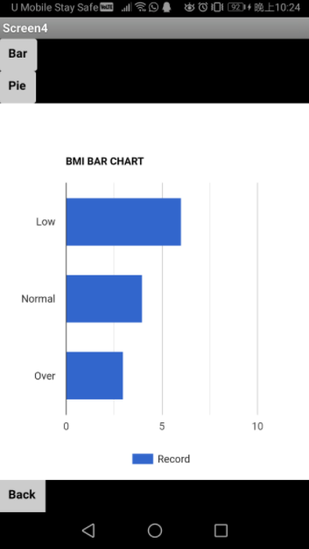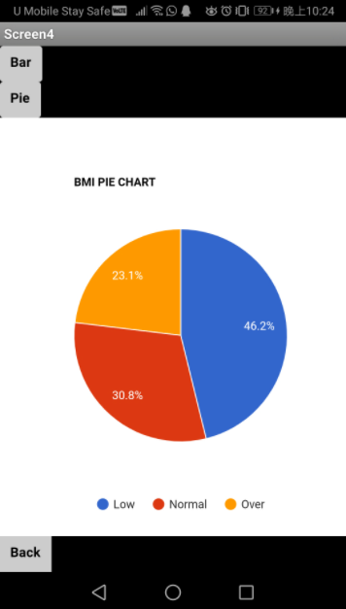

The chart blocks in MIT App Inventor:

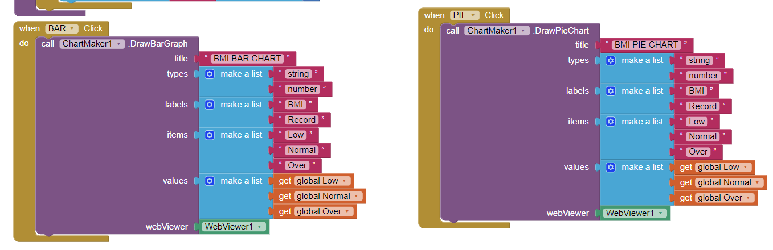

**Link to Github:**

https://github.com/1171103091/TCC-3141---Cloud-Computing